

THE GAME OF SUPER BATTLESHIP

CIS 200 – Program 1 Part 2



July 8, 2021

Your Name

* 1. **Problem Statement**

The client you built the first prototype battleship game for is unhappy with the code organization and asks you to refactor your code in order to help support the modifications to their requirements of Super Battleship and to help make future updates to the game easier. The client reiterates the previous requirements highlighting the changes for you to implement in the first prototype. The client is adamant that the changes can be completed in the next sprint and be ready for public release on the 16th of July by midnight as so much of the project has already been completed. However, if functionality or requirements were incomplete or missing in Program 1 Part 1 this is also your chance to improve your code and complete the missing requirements.

You will be required to implement a working game of Super Battleship in C++ using the console window to show the playing boards for each player. The game will be implemented as per the following specifications:

* + The game board must be implemented as a multidimensional char array of size 10 x 10 o You must not use vectors or other data structures to implement the game board.
  + o You must not use global variables:
  + o You must design the board so that it matches clearly visible “squares” as seen in the provided example screenshots.
  + o Player game pieces will be denoted by: ▪ ‘C’ for Carrier
  + ▪ ‘B’ for Battleship
  + ▪ ‘D’ for Destroyer
  + ▪ ‘S’ for Sub
  + ▪ ‘P’ for Patrol Boat
  + ▪ ‘X’ for a hit ship
  + ▪ ‘O’ for a missed shot
  + ▪ ‘ ‘ for empty (a single space)
  + • This program must be implemented with the following **classes** each of which will be further defined. Classes must be implemented with separate source (.cpp) and header (.h) files. o You must use these class names: ▪ Ship
  + ▪ Carrier
  + ▪ Battleship
  + ▪ Destroyer
  + ▪ Submarine
  + ▪ PTBoat
  + ▪ Player

**Class Ship**

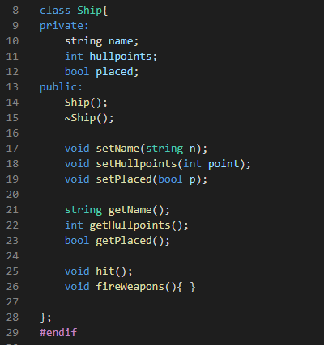

**Class Carrier**

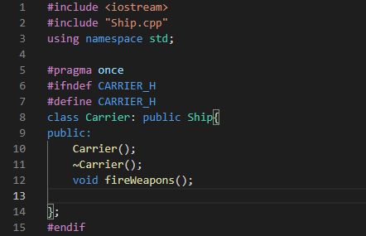

**Class Battle Ship**

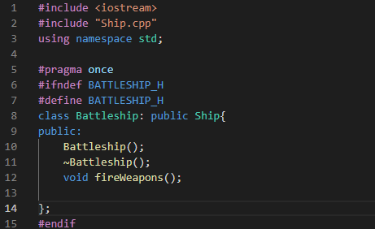

**Class Destroyer:**

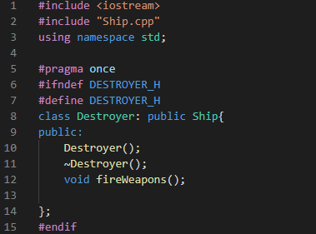

**Class submarine:**

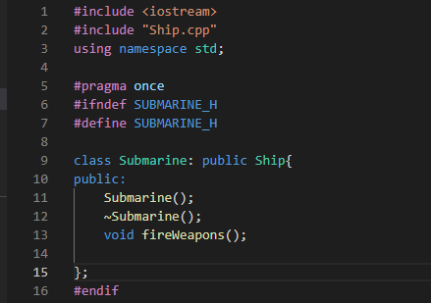

**Class PT Boat:**

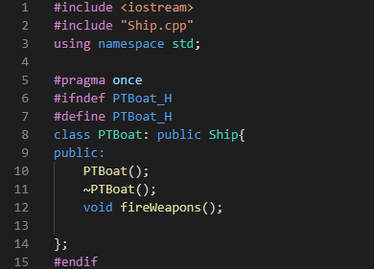

**Class Player:**

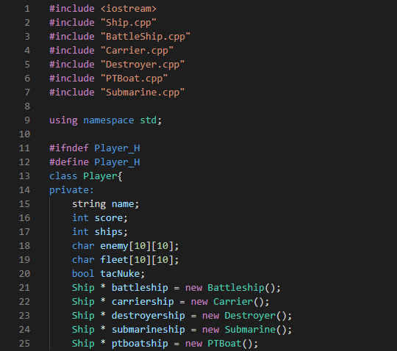

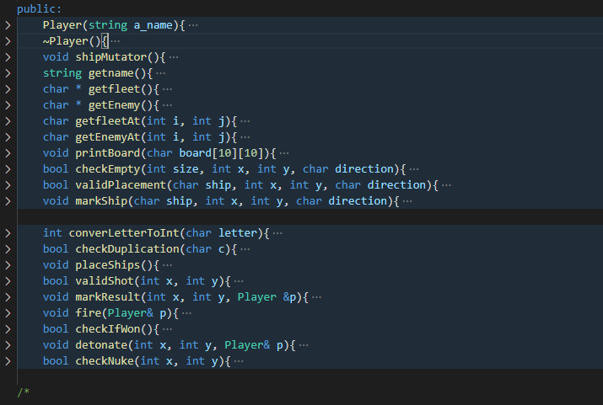

* 1. **UML Class Diagram**
  2. 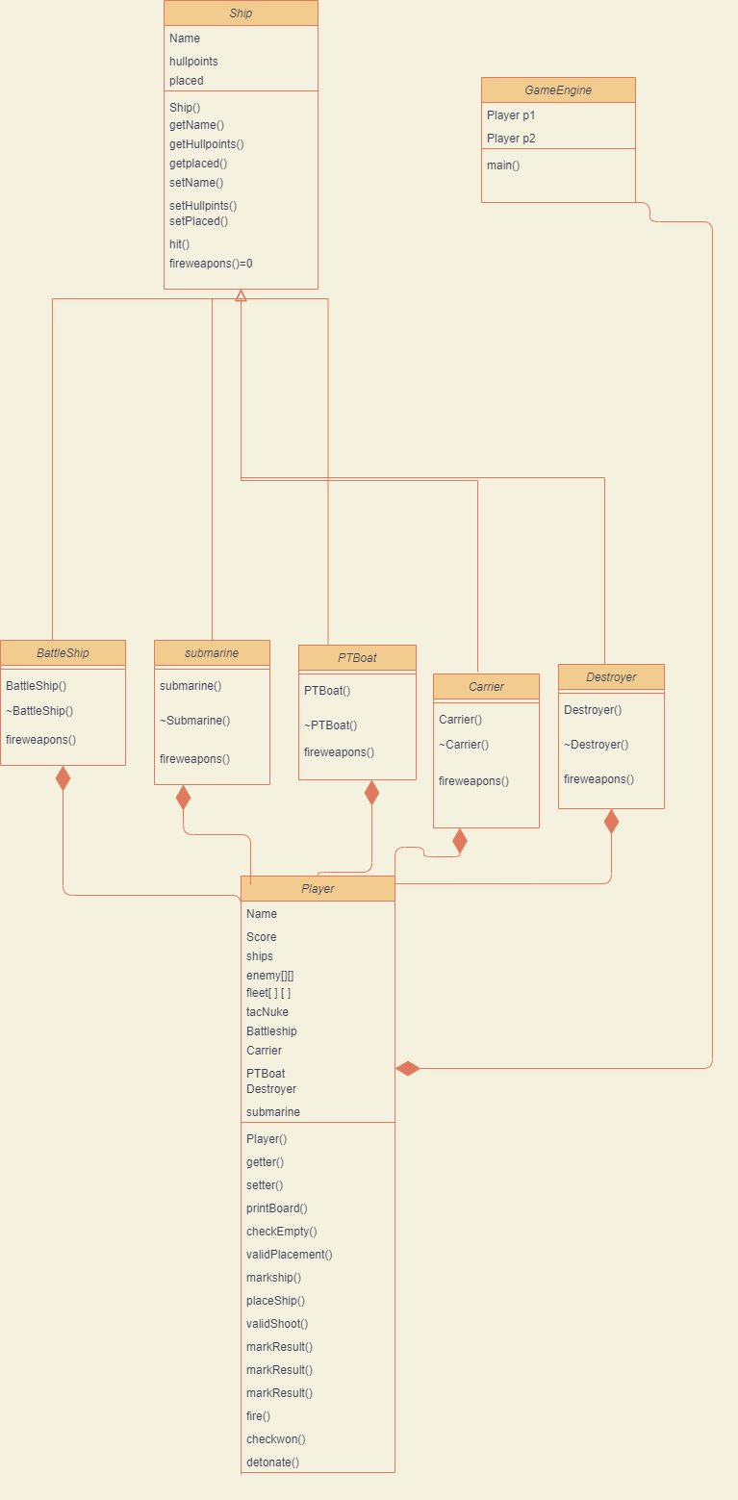
  3. **TEST CASE:**
  4. 